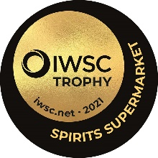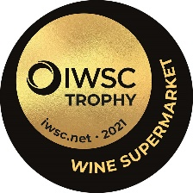

IWSC Retailer Awards
Wine Supermarket & Spirit Supermarket
Entry Form 2021
Criteria:
Supermarkets are invited to take part, free of charge, by completing the questionnaire below. The award will be based on the achievement in the last 12 months and the plans for the forthcoming year.

Submitting your entry:
Please return this questionnaire to Kirsten.Ferrone@iwsc.net by 5th March 2021.
Please send any additional online material by wetransfer link.

COMPANY INFORMATION
Company:
Contact name:
Address:
 |  |  |  | Post code
Phone: |  | Email:

The following question is for judging purposes only and will not be published:

Number of staff employed:
<10,000 10,000 – 50,000 50-100,000 >100,000

SERVICE
What techniques do you use to engage with your customers and to encourage them to trade up? (max 100 words)
What service do you offer for home delivery? (max 100 words)
How are you trying to improve the shopping experience? (max 100 words)
What wine and other training do you offer to your staff? (max 100 words)
What have you achieved in the last 12 months toward promoting sustainability? Please give examples of your Scope 3 emissions and your planned objectives with customer education. What is your resource allocation to achieving these objectives? (max 500 words)

Please include any photos relevant to answer – up to a maximum of 10 for this section.
WINE RANGE
How diverse is your wine range and how have you innovated this in the last 12 months? (max 100 words)
How many new wine lines have you introduced in the last 12 months? How many new lines do you plan to introduce in the next 12 months? (max 200 words)
How many own label wines do you stock, and have you increased or decreased this number? (max 100 words)
What is the business rationale behind your wine own-label range? (max 100 words)
How do you help your customers to navigate your wine range? e.g. by taste, food matching, price etc. (max 100 words)

Please include any photos relevant to answer – up to a maximum of 10

WHY YOU?
What top three things innovations and changes do you wish to achieve in the next 12 months that will set you apart from your competitors? (max 300 words)

Describe what you have achieved in the last 12 months that sets you apart from your competitors and makes you the Wine Supermarket of the Year? (max 300 words)

SPIRITS RANGE
How diverse is your spirits range and how have you innovated this in the last 12 months? (max 100 words)
How many new spirit lines have you introduced in the last 12 months? How many new spirit lines do you plan to introduce in the next 12 months? (max 100 words)
How many own labels do you stock, and have you increased or decreased this number? (max 100 words)
What is the business rationale behind your spirits own-label range? (max 100 words)
How do you help your customers to select from your spirits range? e.g. by category, quality designation, serving suggestion, price etc. (max 100 words)

Please include any photos relevant to your answer – up to a maximum of 10.

WHY YOU?
What top three things innovations and changes do you wish to achieve in the next 12 months that will set you apart from your competitors? (max 300 words)

Describe what you have achieved in the last 12 months that sets you apart from your competitors and makes you the Spirits Supermarket of the Year? (max 300 words)

Many thanks for your participation.

