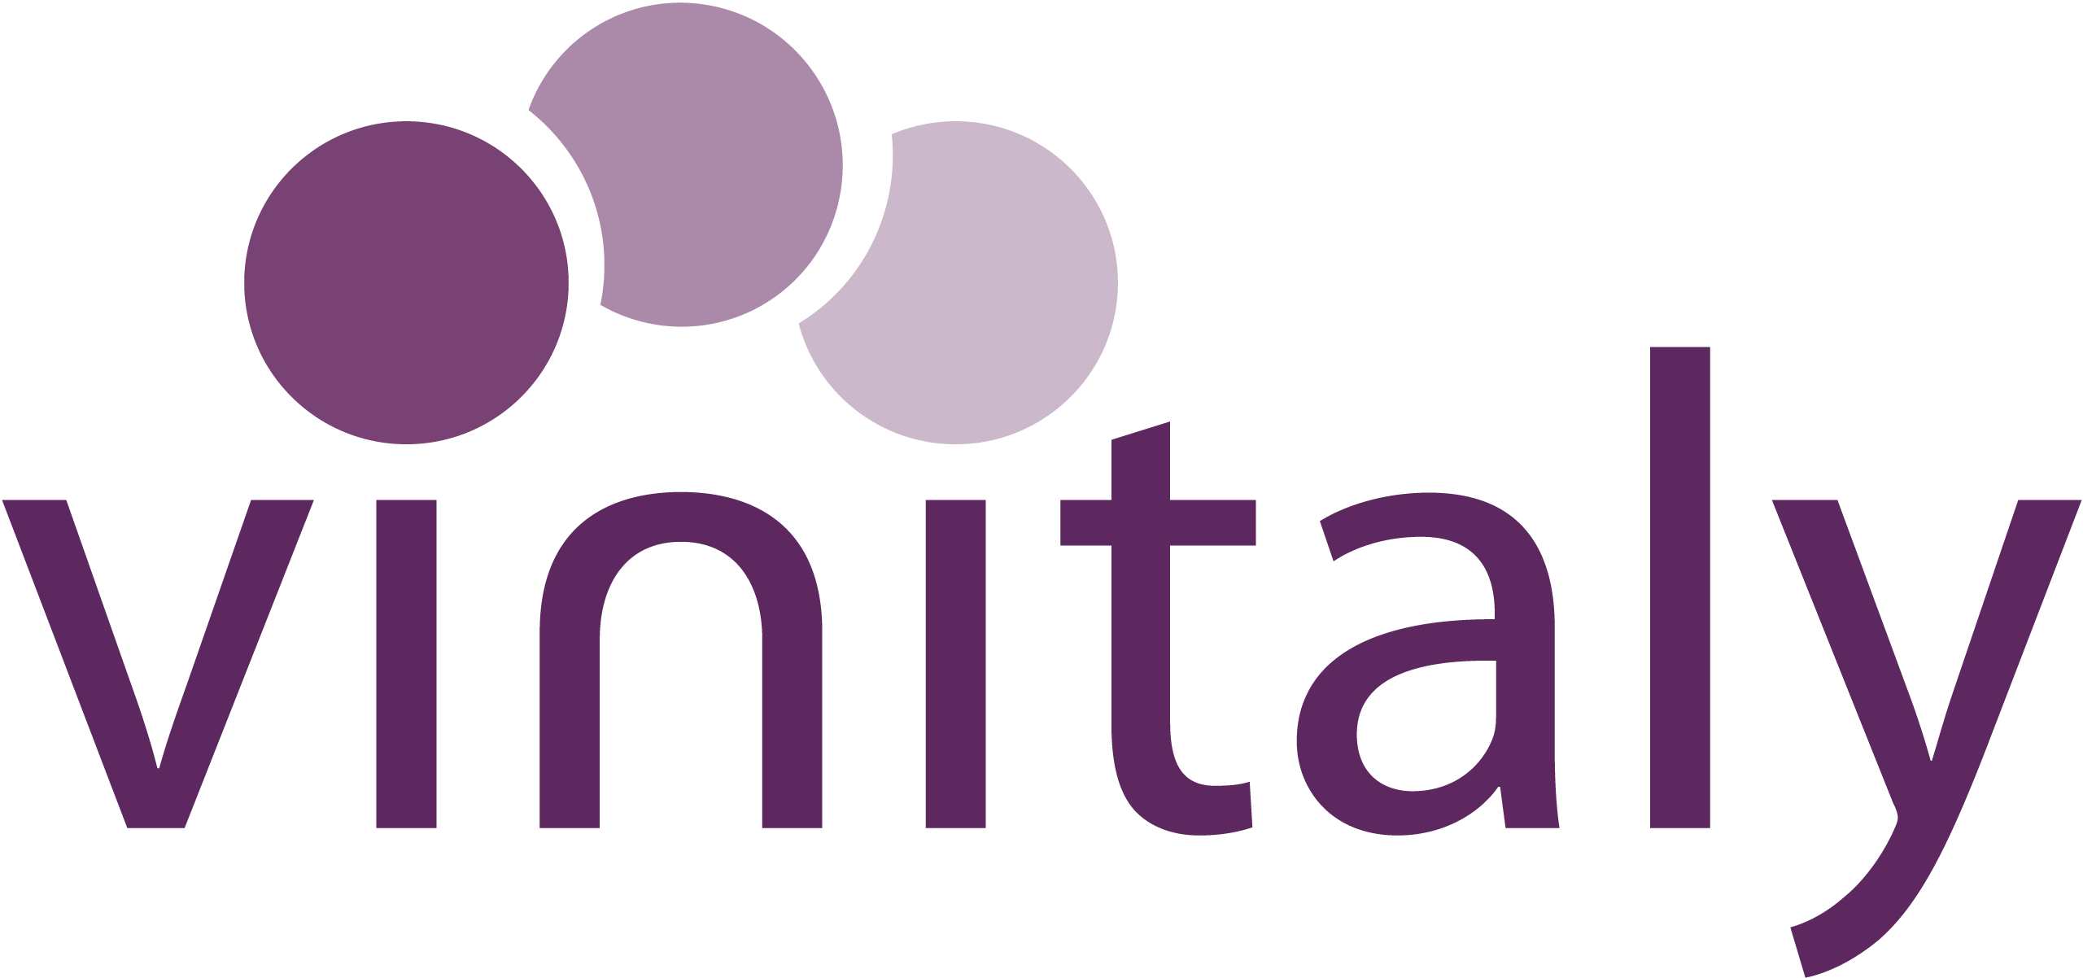
IWSC 2023 Wine Communicator
Sponsored by Vinitaly
Entry Form

The search is on to find the winner of the IWSC’s 2023 Wine Communicator award, sponsored by Vinitaly. Entries are open for the award that recognises the very finest talent in wine communication.
Organised by the IWSC, and sponsored by Vinitaly, the world’s largest wine exhibition, the competition is open to individuals or organisations whose communication skills have made an exceptional contribution towards the promotion of wine.
The widely regarded accolade is open to entrants from all over the globe, across the worlds of publishing, journalism, social media, broadcasting and education, and is judged by a panel of communication experts, including previous winners of this accolade, as well as a member of the IWSC team and a representative from Vinitaly.
Entry is free of charge.
Entry criteria:
Honoring excellence in effective, and meaningful communication across multi-channels, the Wine Communicator will have spent many years of their professional lives dedicated to communication across:
- Publishing (books, reviews, biographies and/or autobiographies)
- Journalism (specialist press, special feature collections, newspaper, magazine and/or digest articles)
- Broadcasting, radio, television and film (writing, presenting, producing and/or directing)
- Online (social media, blogging and/or website)
- Wine consumer education
Candidates must be/have been:
- Actively involved in communications in the wine industry and across different channels
- Recognised as a role model for trade and/or consumer
- Demonstrate ethics and professionalism in communication
- Recognised as an advocate in the wine industry
- Earned a reputation as being highly credible with a variety of audiences.
The award will be based on the achievement in the past 12 months, between the period of July 2021 – June 2022.
The deadline for entry 19 August and a shortlist of entrants will be shared during the first week of September, ahead of the winner being announced on 29 September.
Following the announcement, the IWSC will look forward to working closely with the winner in a program of activations throughout the year including features in the IWSC’s consumer magazine, Club Oenologique. The winner will also be offered the opportunity to attend Vinitaly in April 2023 and host a masterclass.
Good luck.
Submitting your entry:
Please return this completed questionnaire to Teresa.LaBraca@iwsc.net by Friday 19 August 2022.

NOMINEE’S CONTACT INFORMATION
Full name:
Country of residence:
Email:
Website:
Social media handle(s):

ABOUT YOU
Biography

YOUR ACHIEVEMENTS
List of notable achievements:

WHY YOU?
What are your plans for the next 12 months:

Why do you feel placed to be the next IWSC Wine Communicator?

Please return this completed questionnaire to Teresa.LaBraca@iwsc.net by Friday 19 August 2022.
About Vinitaly
Vinitaly has supported wine industry producers since 1967, making an active contribution to the growth of the wine system by creating business opportunities in Italy and around the world, as well as promoting occasions for networking between wine-makers and sector professionals.
Vinitaly promotes wine culture 365 days a year through qualified training courses as well as events across the globe. It’s biggest annual event is hosted each April in Verona City and comprises 400 events over 4 days, including theme-based pavilions, B2B meetings, guided tastings, walk-around tastings, focus analysis of the main markets, conferences and gala dinners.
https://www.vinitaly.com/en

