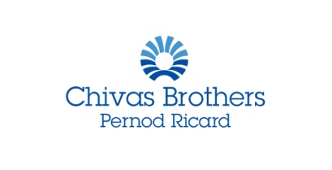

2021 IWSC Spirits Communicator- In partnership with Chivas Brothers

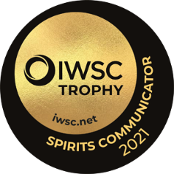
The hunt is on for the IWSC 2021 Spirits Communicator! Entries are now open for the award that recognises the very finest talent in spirit communication.
Organised by IWSC, in partnership with global drinks producer and exports company, Chivas Brothers, the competition is open to individuals or organisations whose communication skills have made an exceptional contribution towards the promotion of spirits.
The widely regarded accolade is open to entrants from across the worlds of publishing, journalism, broadcasting and education, and is judged by a panel of experts in the field.
The judging will take place at the beginning of October and the winner of the 2021 Spirits Communicator will be announced at our awards ceremony on 18 November 2020. This year’s Awards ceremony will take place as a virtual broadcast on YouTube Premieres. To find out more about the event, go to www.iwsc.net.
Throughout 2021, IWSC and its consumer arm Club Oenologique will then work closely with the Spirits Communicator across a range of trade- and consumer-facing projects.
Candidates are required to work in one or more of the following:
- Publishing (books, reviews, biographies and autobiographies)
- Journalism (specialist press, special feature collections, newspaper, magazine and digest articles)
- Broadcasting, radio, television and film (writing, presenting, producing and directing)
- Online (social media, blogging, website)
- Spirit consumer education
Our 2021 Spirits Communicator will probably have spent many years of their professional lives associated with spirits - although only their promotional work or special projects from the last year (2020) will be considered for this year’s trophy.

__________________________________________________________________________________
IWSC Spirits Communicator entry form:

- 1 Biography (please outline below, or send a CV via email attachment)

- 2 Why do you feel you are well placed to be the next IWSC Spirits Communicator?

- 3 Notable achievements in 2019-2020:

- 4 How did you adapt your communication skills during the lockdown?

- 5 Your plan for the next 12 months:

- 6 If you were to win, how would you use this opportunity?

- 7 A high-res headshot

Please send the completed form with any documents attached back to Kirsten.ferrone@iwsc.net by 23rd September.
If you would like to send in any supporting materials for the judges to take into consideration - for example books, please send to;
IWSC Spirits Communicator
C/O Kirsten Ferrone.
IWSC - Building 17
Stovolds Hill
Dunsfold Park
Cranleigh
Surrey
England
GU6 8TB

