2021 IWSC Emerging Talent in the Spirit Industry
In Partnership with Whyte & Mackay
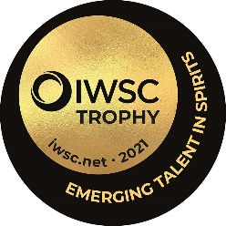

The hunt is on for the 2021 Emerging Talent in the Spirits Industry
Criteria:

Are you the spirits industry’s next big name? The trophy is awarded to someone who demonstrates a real dedication and passion for spirits communication and education. If you are disrupting the norms, communicating with energy or launching a brand-new way of educating the consumer this is the award for you.
This entry is open to UK applicants.
The judging will take place at the end of March and the winner of the 2021 IWSC Emerging Talent in Spirit will be announced in April 2021.
The winner will be invited to take a residency with Greg Glass and Shane Healey in Whyte & Mackay Production Centre of Excellence, Inverness.

__________________________________________________________________________________
CONTACT INFORMATION
Contact name:
Address:
 |  |  |  | Post code
Phone: |  | Email:

Social Media handles: ___________________________
Website or blog (if applicable): __________________________________

_________________________________________________________________________________

IWSC Emerging Talent in Spirit Entry Form:

- 1 Biography (you can send a CV via email attachment)

- 2 What inspired you to start the journey with your current initiative?

- 3 What makes your initiative unique and engaging?

- 4 What do you feel are your top 3 achievements within your initiative?

- 5 What challenges have you had to overcome with setting up and growing your ideas?

- 6 Explain why you should win this award and how it will make a difference to your vision?

Please email the completed form with a hi-res headshot photograph and any additional online material to Kirsten.ferrone@iwsc.net by 5th March.

Many thanks for your application.

