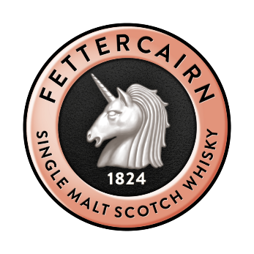

Emerging Talent in Spirits Communication

This award is sponsored by Fettercairn Whisky

Entry Form 2024

Are you or is someone you know setting out on a journey to become the next big name in spirits communication? We want to hear from you. This award has been specially created for a new generation of communicators within the spirits industry. Communicators who are using innovative and creative ways to share their knowledge and passion with consumers and/or the wider industry.

Whether you are communicating with your audience about spirits through publishing, journalism, social media or broadcasting, we want to hear from you.

A £2.5k travel bursary will be awarded to the winner of this award.

If you are entering for yourself, or if you are nominating someone, please ensure you fill in the correct sections below.

NOMINEE CONTACT INFORMATION – please complete
Nominee’s name:
Nominee’s email address:
Nominee’s country of residence:
Nominee’s mobile number:
Nominee’s social media handles:
If you are entering this award on behalf of someone else, please let us know why you think they deserve to win using the space below. Then please return this form to marketing@iwsc.net
The IWSC will follow up with your nominee for further information.
If you are entering yourself, please continue to complete all the questions below and return your completed entry to marketing@iwsc.net with a copy of your headshot (JPEG/EPG) no later than Friday 26 January 2024.
Judging will take place in early February and the winner announced w/c 19 February 2024. Good luck!

FURTHER INFORMATION
Company name (if applicable):
Years in industry:

ABOUT YOU
FURTHER INFORMATION
Please answer the questions below to help our judges decide why you deserve to receive this accolade. Good luck.

Please attach your CV with your entry, or share your work experience below:

Please share with us some of your most recent communications (as URL links or please attach with your entry) which illustrate how you are trying to engage your audience. Can you also provide an explanation of why you have selected these, as your examples, potential audience reach or anything else that will help convey your style of communication to our judges.

What platforms do you use to communicate with your audience? Include URLs where appropriate.

What communication outlets do you think work well in the drinks industry and why?

And what communication opportunities do you think there are for the wider spirits industry that are not being maximised or made the most of, and how do you think this can be improved?

Are there any individuals within the spirits communication field that inspire you? Please explain how they inspire you.

What hopes do you have for your future in drinks communication?

If you had the opportunity to communicate about anything, what would it be?

Why do you think you deserve to win this award?

What have been your biggest successes over the last year?

The prize for this award is a £2,500 travel bursary. Please explain how you intend to use the prize money.

For our judges to have a better understanding of your personality and unique communication style, this year we are giving entrants the option to submit a short (up to 3 minutes) video to accompany their submission. It is not compulsory, but for entrants who wish to, please feel free to include a recording introducing yourself and explaining more about your communication style, outlets, audience, and your ambitions with your submission.

Thank you for entering the IWSC’s Emerging Talent Awards. Please return your completed form, with your headshot (and optional video) to marketing@iwsc.net before Friday 26 January 2024.

