2021 IWSC Emerging Talent in the Wine Industry
In Partnership with
Consorzio Conegliano Valdobbiadene Prosecco Superiore DOCG
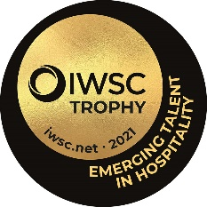

The hunt is on for the 2021 Emerging Talent in the Hospitality Industry
Criteria:
Are you passionate about the customer experience? Are you the best behind the bar? The superior Sommelier?
This trophy is awarded to someone who demonstrates a real dedication, passion and style to their role within the hospitality industry. If you are disrupting the norms, behind a bar, front of house or redefining the way customers interact with drinks, then this is the award for you.
This entry is open to UK applicants.
The judging will take place at the end of March and the winner will be announced in April 2021.
The winner will be invited as a guest of the Conzorzio to Coneglianno Valdobiadenne with trip expenses covered.
__________________________________________________________________________________
CONTACT INFORMATION
Contact name:
Address:
 |  |  |  | Post code
Phone: |  | Email:

Social Media handles: ___________________________
Website or blog (if applicable): __________________________________

_________________________________________________________________________________

IWSC Emerging Talent in Hospitality Entry Form:

- 1 Biography (you can send a CV via email attachment)

- 2 What do you enjoy the most about working in the hospitality industry?

- 3 What are you top three achievements in your current or most recent job role?

- 4 How have you innovated or changed the perception that the wider public have of the hospitality industry?

- 5 What are the top three visions that you would like to see come alive in the hospitality industry?

- 6 Explain why you should win this award and how it will make a difference to your vision?

Please email the completed form with a hi-res headshot photograph and any additional online material to Kirsten.ferrone@iwsc.net by 5th March.

Many thanks for your application.

