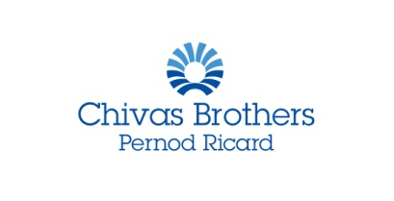

IWSC Spirits Communicator - In partnership with Chivas Brothers

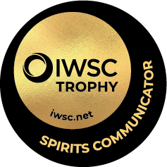
The hunt is on to find the 2022 IWSC Spirits Communicator! Entries are now open for the award that recognises the very finest talent in spirits communication.
Organised by the IWSC, in partnership with global drinks producer Chivas Brothers, the competition is open to individuals or organisations whose communication skills have made an exceptional contribution towards the promotion of spirits.
The widely regarded accolade is open to entrants from across the worlds of publishing, journalism, social media, broadcasting and education, and is judged by a panel of experts in the field.
The judging will take place in September and the winner of the Spirits Communicator will be announced at our exclusive awards ceremony on 21 October 2021. This year’s awards ceremony will take place in Scotland, in honour of our president, Michael Urquhart. To find out more about the event, go to www.iwsc.net
Throughout 2022, the IWSC and its consumer arm Club Oenologique will work closely with the Spirits Communicator across a range of trade- and consumer-facing projects.
The Spirits Communicator will be awarded on 21 October 2021 and the winner will hold the title until the next Spirits Communicator is revealed in 2022.
Candidates are required to work in one or more of the following:
- Publishing (books, reviews, biographies and/or autobiographies)
- Journalism (specialist press, special feature collections, newspaper, magazine and/or digest articles)
- Broadcasting, radio, television and film (writing, presenting, producing and/or directing)
- Online (social media, blogging and/or website)
- Spirit consumer education
Our 2022 Spirits Communicator will probably have spent many years of their professional lives associated with spirits - promotional work or special projects from November 2020 to September 2021 will be considered, as well as 2022 plans.

NOMINEE’S INFORMATION
Contact name:
Address:
 | Post code
Social media handle (s)
Phone: |  | Email

NOMINATOR’S INFORMATION
Contact Name:
Company (if applicable):
Phone: |  | Email:

___________________________________________________________________________
IWSC Spirits Communicator entry form:

- Tell us the name of the person you are nominating and a little bit about them:

- Why do you feel this person is well placed to be the next IWSC Spirits Communicator?

- Their notable achievements in the last 12 months:

- Do you know their plans for the next 12 months?

- Do you have contact details for this person? (Email address or telephone number)

Please send the completed form with any documents attached back to Kirsten.ferrone@iwsc.net by 10th September.

__________________________________________________________________________________
About the IWSC
- The IWSC is the world’s original wine and spirits competition.
- Founded in 1969 by chemist Anton Massel, he created the competition to reward excellence in drinks worldwide, ensuring recognition for the very best wines and spirits. This remains the purpose of the IWSC today.
- For more than 50 years the IWSC has overseen the rigorous judging of wines and spirits in order to share the results with a global audience of drinks enthusiasts.
- Proud to set the international benchmark for quality, the IWSC’s annual results are decided by an impartial judging panel of the world’s leading wine and spirits experts including Master Sommeliers, Masters of Wine, Master Distillers and Blenders.
- Still innovating after half a century, new judging categories include 100% fermented fruit and cider and low and no-alcohol.

About Chivas Brothers
- Chivas Brothers is the Pernod Ricard business dedicated entirely to Scotch whisky.
- Its award-winning portfolio features some of the world’s most revered single malt and blended Scotch whisky brands, including Chivas, Ballantine’s, Royal Salute and The Glenlivet, which are exported from Scotland to over 100 countries worldwide.
- The UK’s No. 2 Scotch whisky producer, Chivas Brothers and its 1,600-strong team across 27 sites and over 30 based internationally, is committed to upholding and protecting the heritage of Scotch and ensuring
- its sustainable future, as well as opening it up to new audiences across the globe.

