HOW TO SHIP YOUR BOTTLES TO THE IWSC USING AN
AN INDEPENDENT COURIER

If you cannot ship your samples using our consolidated service, please follow these instructions.
- A commercial invoice is needed for all entries – please click here for a template. Please list all samples as having a value of €0.
- The invoice must be fixed to the outside of the box and copies handed to the courier.
- Please list entries as Samples for Tasting – No commercial value
- Please make sure all taxes and duties are paid for by you the entrant. IWSC cannot be responsible for these and will not pay them on your behalf.
- Please send all wine to: IWSC C/O SWS, Unit 10 Dana Trading Estate, Transfesa Rd, Paddock Wood, Kent, TN12 6UT, UK
- Please send all spirits to: IWSC c/o Wine Logistics, 14 St George’s Business Park, White Lion Rd, Amersham, Bucks, HP7 9JQ
- Make sure all UK customs and duties are payable by you. IWSC will not accept samples with duty and VAT owing.
- If you are asked for an ENORI code please use IWSC VAT no. 853 914 212

If you have any further questions about shipping your bottles please get in touch on info@iwsc.net
Filling in the Airway Bills for Direct Shipping

DHL
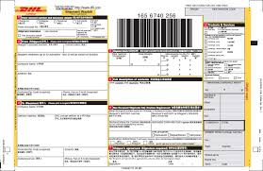
Please tick shipper pays all duties and taxes here on the form.

FEDEX
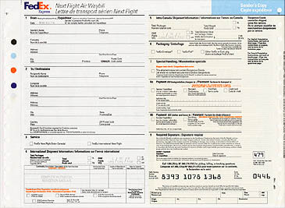
Please tick shipper pays all duties and taxes.

UPS
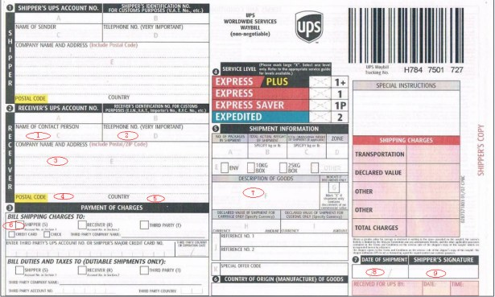
Please tick Shipper pays all duties and taxes.

Duty, Customs and VAT Shipping to UK

Item | Duty | Customs | VAT | Total
Still Wine 5-15% ABV | £2.23 | £ 0.09 | .45 | £2.77
Sparkling Wine | 2.86 | £ 0.195 | .57 | £3.63
Spirits | ABV/100 x £28.74 | 0 | 20% of Duty Rate | Duty + VAT  (eg £13.80 on 40% ABV spirit).

